VISHWAKARMA UNIVERSITY
Academic Year: 2025-26 | Semester II
ADVANCED WEB TECHNOLOGY
NAME OF THE STUDENT : | Aaditya Dhanwate
DEPARTMENT : | ARTIFICIAL INTELLIGENCE & DATA SCIENCE
CLASS / DIV. : | TY / A
SRN : | 31230319
ROLL NO. : | 8

ASSIGNMENT NO.: 07
Create a Local MongoDB Database, Add Sample Data, and Practice Essential CRUD Operations using the MongoDB Shell
OBJECTIVE:
• Create a local MongoDB database (office) with a users collection
• Insert sample documents using insertMany() and verify via MongoDB Compass
• Perform Read (findOne), Update (updateOne with $set), and Delete (deleteOne) operations using the MongoDB shell

Problem Statement: Create a local MongoDB database named 'office', add a 'users' collection, and insert sample documents containing name, age, and city fields. Practice essential CRUD operations — insertMany, findOne, updateOne, and deleteOne — using the MongoDB shell, and verify the data changes using MongoDB Compass.
Output:
1. Inserting Sample Documents using insertMany() in MongoDB Shell
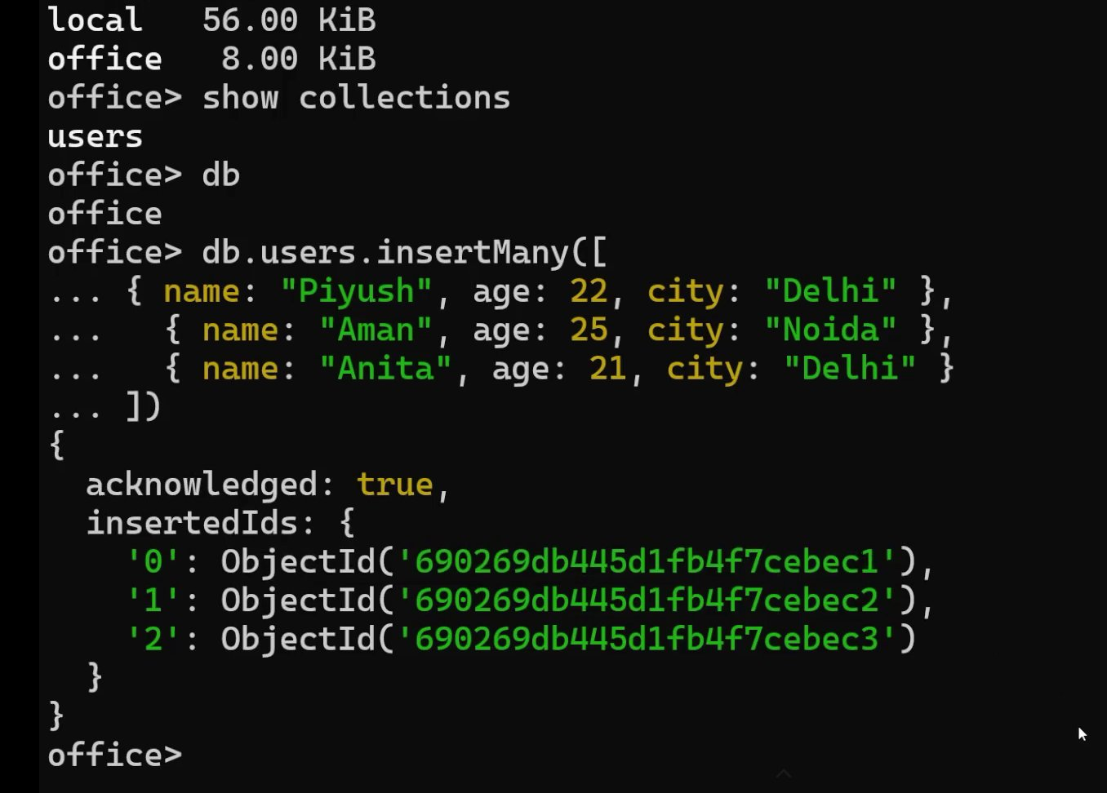
2. All Inserted Documents Visible in MongoDB Compass (office > users)
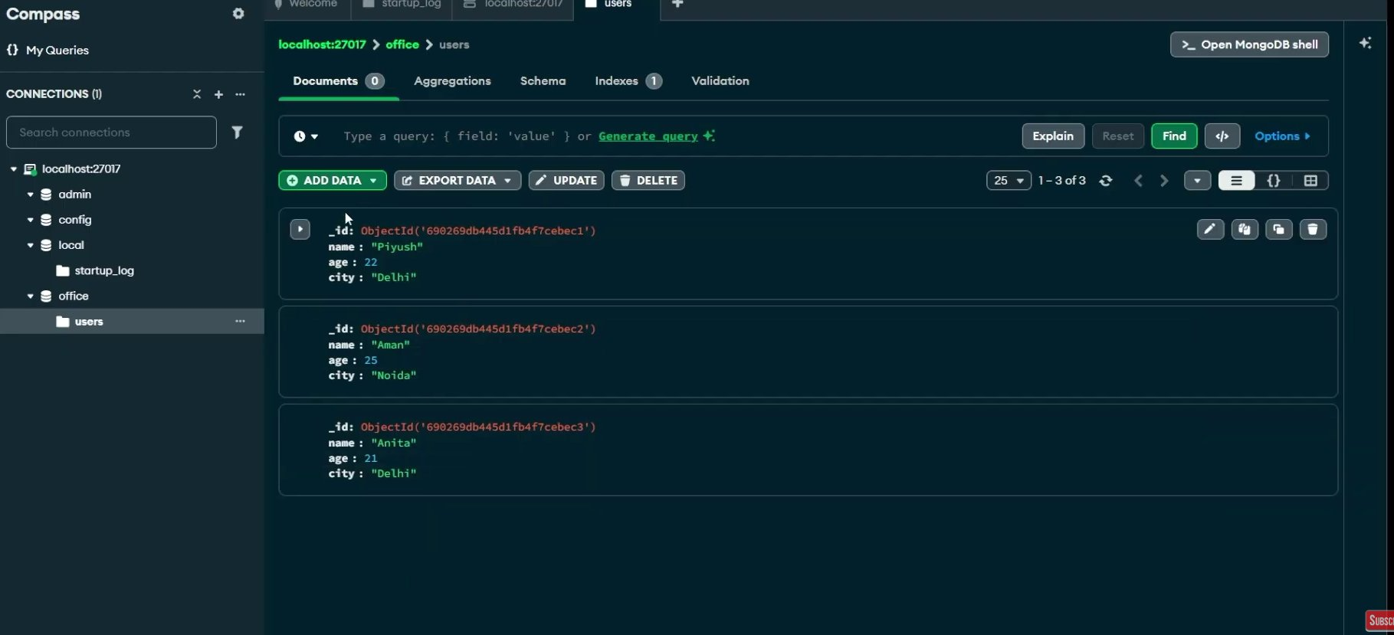
3. Read Operation – findOne() to Retrieve a Specific Document
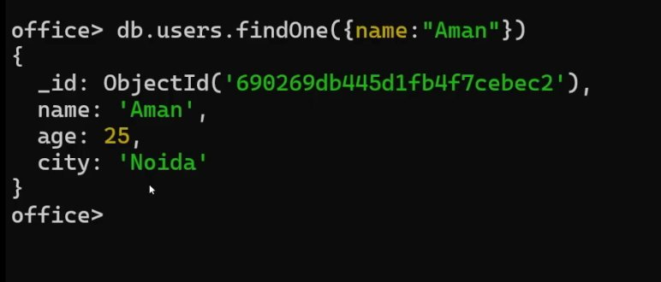
4. Update Operation – updateOne() with $set to Modify a Document
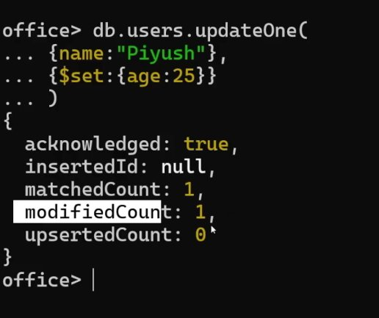
5. Delete Operation – deleteOne() to Remove a Document
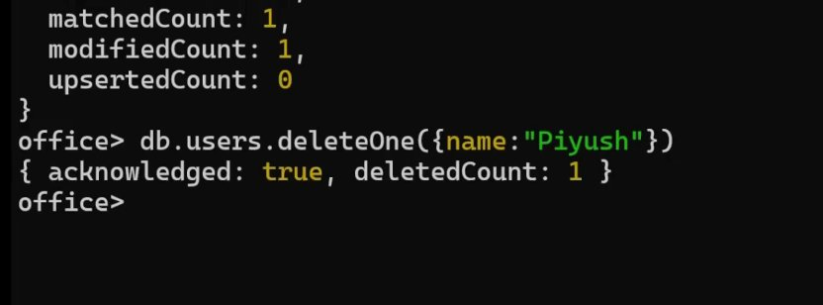
6. MongoDB Compass After Delete – Remaining 2 Documents (Aman & Anita)
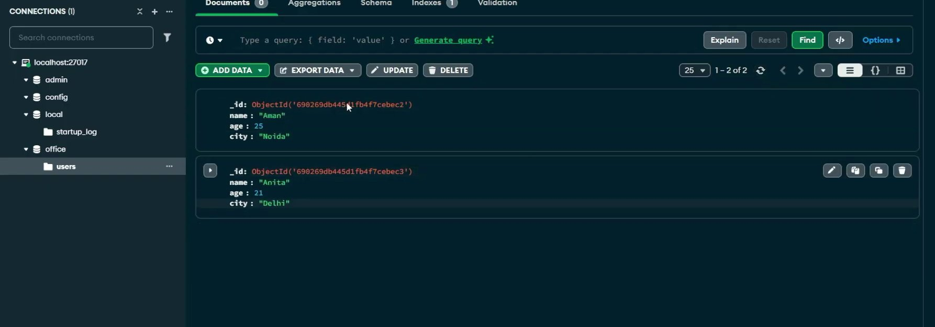

Conclusion:
In this assignment, a local MongoDB database named 'office' was created with a 'users' collection. Sample documents were inserted using insertMany() and verified in MongoDB Compass. All four essential CRUD operations were successfully demonstrated: Create (insertMany), Read (findOne), Update (updateOne with $set to change Piyush's age to 25), and Delete (deleteOne to remove Piyush's record). The final state showing only Aman and Anita remaining was confirmed in MongoDB Compass.

